DLD Lab 3(s0ftware)

Mohammad Yehya Hayati, 21K-3309, BCS-2G

Table of Contents

**Exercise #1:** 2

**Exercise #2:** 3

**Exercise #3:** 4

**Exercise #4:** 4

**Exercise #5:** 5

**Exercise #6:** 5

**Exercise #7:** 6

**Exercise #8:** 6

**True/False:** 7

# **Exercise #1:**

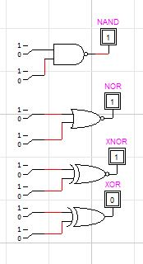

|  |  |  |  |  |  |
| --- | --- | --- | --- | --- | --- |
| **A** | **B** | **NAND** | **NOR** | **XNOR** | **XOR** |
| 0 | 0 | 1 | 1 | 1 | 0 |
| 0 | 1 | 1 | 0 | 0 | 1 |
| 1 | 0 | 1 | 0 | 0 | 1 |
| 1 | 1 | 0 | 0 | 1 | 0 |

# **Exercise #2:**

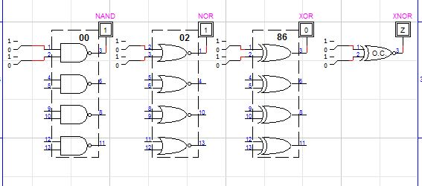

Truth Table is same as the table for Q1

# **Exercise #3:**

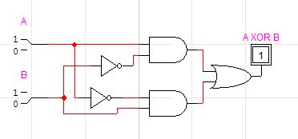

|  |  |  |
| --- | --- | --- |
| **A** | **B** | **A XOR B** |
| 0 | 0 | 0 |
| 0 | 1 | 1 |
| 1 | 0 | 1 |
| 1 | 1 | 0 |

# **Exercise #4:**

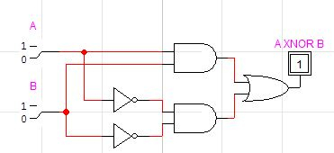

|  |  |  |
| --- | --- | --- |
| **A** | **B** | **A XNOR B** |
| 0 | 0 | 1 |
| 0 | 1 | 0 |
| 1 | 0 | 0 |
| 1 | 1 | 1 |

# **Exercise #5:**

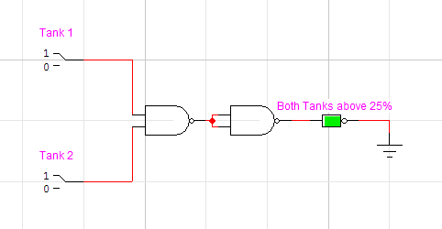

|  |  |  |
| --- | --- | --- |
| **Tank 1** | **Tank 2** | **Output (LED-Green)** |
| 0 | 0 | Off |
| 0 | 1 | Off |
| 1 | 0 | Off |
| 1 | 1 | On |

# **Exercise #6:**

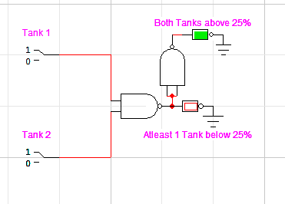

|  |  |  |  |
| --- | --- | --- | --- |
| **Tank 1** | **Tank 2** | **Output (LED-Green)** | **Output (LED-Red)** |
| 0 | 0 | Off | On |
| 0 | 1 | Off | On |
| 1 | 0 | Off | On |
| 1 | 1 | On | Off |

# **Exercise #7:**

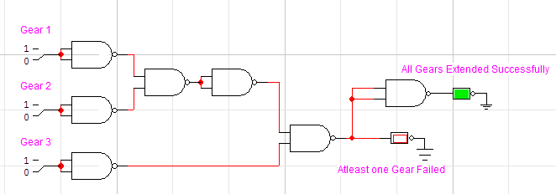

|  |  |  |  |  |
| --- | --- | --- | --- | --- |
| **Gear 1** | **Gear 2** | **Gear 3** | **Output (LED-Green)** | **Output (LED-Red)** |
| 0 | 0 | 0 | On | Off |
| 0 | 0 | 1 | Off | On |
| 0 | 1 | 0 | Off | On |
| 0 | 1 | 1 | Off | On |
| 1 | 0 | 0 | Off | On |
| 1 | 0 | 1 | Off | On |
| 1 | 1 | 0 | Off | On |
| 1 | 1 | 1 | Off | On |

# 

# **Exercise #8:**

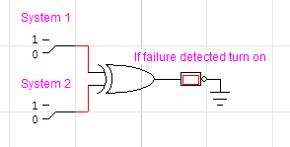

Same as above but using NAND, NOR

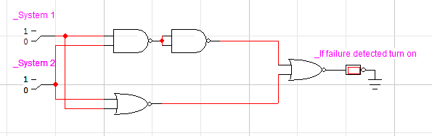

|  |  |  |
| --- | --- | --- |
| **System 1** | **System 2** | **Output (LED-Red)** |
| 0 | 0 | 0 |
| 0 | 1 | 1 |
| 1 | 0 | 1 |
| 1 | 1 | 0 |

# **True/False:**

1.True

2.True

3.False

4.False

5.True

6.True

7.False